Auckland Climbing College Series – Event 1
2024 EVENT HEALTH & SAFETY PLAN
SECTION 1: Event Information
Event Name: Auckland Climbing College Series: event 3 |  | This Plan Dated: 11/04/2024
Event Location | 5 Waikaukau Road - Vertical Adventures
Event Date | 23/06/2024
Organisation delivering event | Auckland Sport Climbing
Number of Participants | Unknown – (160)
Number of Schools Participating | Unknown – 42 estimate

Event overview. Provide a brief summary of what your event will involve.
Sport Climbing – Indoor Climbing
The event is one of a series of 4 events which includes the 2 disciplines of Climbing
Event 3: Vertical Adventures
Consists of 30 Top rope – (traditional climbing with present and secure ropes)

SECTION 2: Event Personnel.
Name | Role | Responsibility | Contact Details
Sandra Bolland | Belayers  Manager | Belayers | accseries1@gmail.com
Chris Wade | Head Judge | Judges | chris@wadeysoft.com
Michael O’Keefe | MC & President ASC | Front of house | Michael.j.ok@gmail.com
John McKnight | Scoring software | Scoring Software | jmck010967@gmail.com
Sandra Bolland | Event Coordinator | Overall responsibility | accseries1@gmail.com
TBA | Disputes &  Discipline | Convening & Chairing disputes panel

.

SECTION 3: Risk Assessments and Management
3A: Sport Specific Risk Assessment & Management Plan
Risk Assessment Key
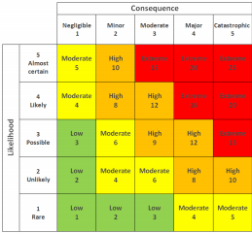

Core Health and Safety Mitigation program:
Top rope belaying identified as key risk factor: to mitigate any potential risk only experienced belayers identified from the volunteer base permitted to belay top rope climbs. Volunteer top rope belayers are co-ordinated in advance.

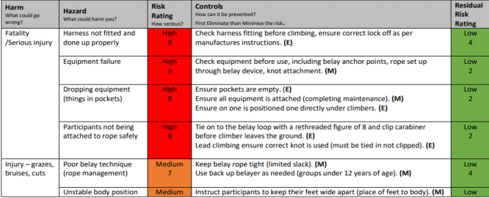
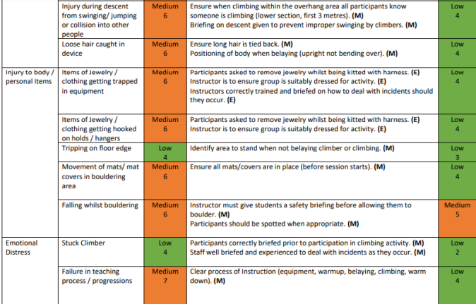

7
Sport Specific Risk Assessment
Hazard or Risk identified. | Risk Level | Level of Control  (see previous page) |  |  |  |  | Action
What could go wrong? | Low  Med  High  Extreme | Eliminate | Substitute | Engineer  control | Admin  Control | PPE | How will we prevent it? | Person  responsible | What we will do if it happens?
Fall from Height | High | No | No | Yes | Yes | Yes | Only roped climbing will be allowed on the wall. Top ropes will be used with double carabiners attached to rope ends so no knot tying is required of participants. The two carabiners will connect to the participants climbing harness and these to be checked by the belayer prior to climber leaving the ground. Only experienced adults with their VA belay top rope licence are permitted to belay. In addition Grigri belay devices will be used to reduce the risk of rope slippage when a climber falls. | Event Manager | onsite first aid  Emergency Services if required
Falling objects | Med | No | No | Yes | Yes | No | Climbers to remove items from pockets, Effective group management and briefing. | Event Manager | onsite first aid  Emergency Services if required
Equipment failure | High | No | No | Yes | Yes | Yes | Ensure correct fitting and use of harnesses, the condition of all equipment to be assessed prior to use, suspect items removed from service.  Gym Management to ensure Autobelays are in good operating condition. | Event Manager | onsite first aid Emergency Services if required
Holds spinning /  breaking | Med | Yes | No | Yes | No | No | Condition of holds, monitored, on a regular basis. Holds removed from wall or re-secured prior to commencing session. | Event  Manager  Route Setters | Route Setter to Repair or Replace before next Competitor
Muscle / Joint injuries | Med | No | No | Yes | No | Yes | Use appropriate climbing specific warm-up activities Recognition of overuse injuries, session managed with rests and recovery time | Team  Managers  Rock climbing gym staff | onsite first aid

3B: Venue Specific Risk Assessment & Management Plan – you may have already included the risks specific to your sport in the Event Risk Assessment above. If you have not done so, please provide a risk assessment specific to the hazards in your sport here OR if your NSO has supplied you with a Sport Specific Risk Assessment & Management Plan, please attach it to this document.

3B: Venue Safety Plan – including Emergency Evacuation Procedures. Please attach a copy of the Venue Safety plan to this document. The Venue Management will be able to supply you with this.
Venue specific plan attached

SECTION 4: Core Provisions and Communications.

Core Provisions: Please give details of the following core provisions as they apply to your event or state NA if they do not apply
Item. | Provider | Person  Responsible | Contact | Management Notes
First Aid and Medical services | Venue | Duty Manager | TBA
Drinking water | Venue | ON site staff |  | The gym has a filtered water fountain that participants can fill water bottles from. Water and drinks also able to be purchased at counter
Food | Personal |  |  | Snack bars etc available for purchase at counter
Shade | Venue |  |  | N/A - Indoors
Toilets | Venue |  |  | Separate male and female toilets

Event Security | N/A
Waste Management | Venue |  |  | Bins onsite, recycling and general rubbish
Spectator Controls | Club leadership | Michael  O’Keefe | Michael.j.ok@gmail.com
Parking | Venue |  |  | Parking in carpark and spillover on street in need.
Media |  |  |  | TBA

Event Communications Plan. Please give details of the following as they apply to your event.
Communication Item | Person Responsible | Audience | When? | Notes – eg Content
Pre Event Info – to schools, participants | Sandra Bolland | Schools | Prior the event | Flyer and school information for registering via College Sport Auckland.  Reminder information email to go to schools to forward onto parents competition week, it is also on ACCSeries website.
Event Briefing – Safety Briefing, Event info for students, coaches, managers | Michael O’Keefe |  | On day – 10 min prior
Event Day Communications – Cancellations, changes, weather | Michael O’Keefe |  | On Day | Weather no issue – indoor event
Emergency Communications - evacuation, lost person,  emergency services, notification to schools/parents/media | Michael O’Keefe | Schools, parents, managers | On day | Contact details on google drive accessible online, hardcopy at event
Media information | Sandra Bolland | Parents/ Climbers | Prior & after the event | Before :  Entry & competition information on College Sport Akl website.  Event Flyer on ACCS series Facebook page & Akl sport climbing club website.  After:  Results posted on College Sport Akl web page & ACCSeries Facebook page & Akl sport climbing club website.

Covid Protocols:
Level 1: Standard sanitisation practises
Level 2: Provision of Zoono sanitiser product for all participants, no chalk use, 1m separation protocols in place.
Masks must be worn when by all those who are not climbing on the wall.
Vertical Adventures EMERGENCY STRATEGY PLAN
In the event of an incident/accident:
- Inform the Primary staff member immediately.
- Stay calm
LIFE THREATENING/SERIOUS HARM INJURY
• First Aid FIRST.
o Ensure there is no danger to yourself.
o Ensure patient is not moved if a spinal injury is suspected.
o Ensure patient has an airway.
o Have someone dial 111 for Ambulance.
o Assess ABC’s. If no ABC begin CPR .
o If ABC present, treat for shock & monitor/comfort patient.
o Perform any other necessary first aid.
o Give some privacy, (cordon off area if possible).
o Contact any family members if they are not on site.
• Incident Reporting
o Ensure both our Incident Report (INCIDENT REPORT.doc) and the WORKSAFE SERIOUS INJURY FORM.pdf serious harm forms are filled out.
▪ Definition of Serious Harm on page 4 of this document.
o Contact WORKSAFE by phone ASAP. 0800 030 040 Further contact details on page 4 of this document.
11

o Barricade off the incident scene (including rope/belay unit) and do not disturb until clearance is authorised by a health and safety inspector from MBIE.
o Call Darrin and branch manager ASAP.
o Scan and email WORKSAFE SERIOUS INJURY FORM.pdf to MBIE/WORKSAFE once complete.
NON-SERIOUS HARM INJURY
• First Aid FIRST
o Assess situation
o If patient is in pain when moved.
▪ Assume Serious Harm Injury and follow above plan.
o If patient is mobile – suggest they seek medical attention.
o Perform first aid if required/possible
• Incident Reporting
o Ensure our Incident Report is filled out. Call patient after a few days to check on condition.
EVACUATION PLAN IN EVENT OF FIRE
• Direct customers to exit through main door and meet by building across car park. • Call Fire service • Manager and appointed Staff to check:
o Upstairs above boulder
o Upstairs above counter
o All toilets / change rooms
o Route-set room
o Cage of doom/ under stairs
o Inside abseil tower
o Boulder caves

Vertical Adventures
CRISIS MANAGEMENT PLAN
There are three stages to the crisis management plan.
1. Prevention/Preparation
As per the Risk Analysis & Management (RAMs) forms & procedures (which all staff must read and understand), risks will be identified & strategies put in place to isolate/prevent/minimize these risks.
All manager staff to:
• Have current first aid certification.
• Read and understand Emergency Strategy Plan and Incident/Accident procedures and definitions.
2. Action
When incidents/accidents do occur, staff shall act as detailed in the Emergency Strategy Plan. (Also on the RAMs form). Senior staff such as Darrin and the Branch Manager need to be informed as well as WORKSAFE NZ.
3. Review
A review shall be done using the Accident Register / Incident Report forms.
This should be filled out as soon as possible following the event.
All staff should be made aware of all details of any incident / accident that has occurred & also of any action taken.
All staff shall be made aware of any policy changes made to prevent / minimize chances of a re occurrence.
Depending on the situation, different actions are applicable,
3
If there is serious, imminent danger facing a patron, any staff member must do all within their ability to avert the potential accident, while still maintaining their own safety.
If there is potential for injury due to a customer intentionally disregarding safety protocols, staff must intervene, bring the climber safely back to the ground and explain to both the climber and the belayer the potential risks involved in the previous action, ascertain whether or not the Belayer was aware of the potential risk, and adjust their techniques, while maintaining a professional, helpful manner.
If the customer is not seen to be maintaining ‘textbook’ standard techniques, it is at the discretion of the staff member to ascertain the risk involved and intervene if needed as soon as is necessary. If immediate intervention is not required, the staff member should approach the customer on a casual basis when applicable and ‘remind’ them casually how they may wish to alter their technique to make their experience more pleasant.
The customer is seldom intentionally malicious, and the staff member should not attempt to berate the customer if it’s their first indiscretion. If the customer is seen to be intentionally dangerous with blatant disregard to gym protocols, a primary staff member must approach the customer and calmly offer them the options of:
• Having another safety briefing.
• Changing their reckless behaviour.
• Cease climbing.
• It can be helpful to remind them that there are other patrons in the centre that may be offended or may attempt to emulate their behaviour and that it is inappropriate.
4
SERIOUS HARM DEFINITION
Under the Health and Safety at Work Act 2015 (HSWA) you must notify us when certain work-related events occur.
Deaths, injuries or illnesses that are unrelated to work are not notifiable eg:
• A diabetic worker slipping into a coma while at work
• A worker being injured driving to work, when that driving is not part of their work
• Injuries to patients or rest home residents that are triggered by a medical reason (eg injuries from a fall caused by a stroke)
• A worker fainting from a non-work-related cause.
NOTIFIABLE DEATH – must notify immediately 0800 030 040 after 111
NOTIFIABLE INJURY:
• Serious head injury.
• Serious eye injury.
• Serious burn.
• Spinal injury.
• Loss of bodily functions.
• Serious lacerations.
• Skin separation.
• Any injury that requires the person to be admitted to hospital for immediate treatment.
• An injury that requires the person to receive medical treatment within 48 hours of exposure to a substance.

AMPUTATION:
• If a person has suffered the amputation of any part of the body, and the injury requires immediate treatment other than first aid, then you MUST notify WORKSAFE. Includes:
• a limb (arm or leg).
• other parts of the body (hand, foot, finger, toe, nose, ear).
NOTIFIABLE ILLNESS:
If a person contracts an illness because of work and needs to be admitted to hospital for immediate treatment or needs medical treatment within 48 hours of exposure to a substance, then you MUST notify WORKSAFE.
In addition, you MUST notify WORKSAFE if a person contracts a serious illness because of:
▪ providing treatment or care to a person.
▪ contact with human blood or bodily substances.
NOTIFIABLE INCIDENT:
If someone has been exposed to a serious or immediate risk to their health and safety because of an unplanned or uncontrolled work incident, then you MUST notify WORKSAFE as soon as possible.
The definition of serious harm is relevant to employers' duties to manage hazards, notification requirements, employees' rights to refuse to do dangerous work, and inspectors' powers to issue prohibition notices.
WORKSAFE NZ
_{Physical address /} Postal address WorkSafe New Zealand Level 6
86 Customhouse Quay Wellington 6011
New Zealand
Phone: 0800 040 030
PO Box 165
Wellington 6140 New Zealand Fax : (04) 914 6866 (General faxes only)
For more on notifiable events, please see:
http://www.worksafe.govt.nz/worksafe/notifications-forms/notifiable-events
For an online incident report form, please see:
http://forms.worksafe.govt.nz/notifiable-event-notification

