Auckland Climbing College Series – Event 2
2024 EVENT HEALTH & SAFETY PLAN TEMPLATE
SECTION 1: Event Information
Event Name: Auckland Climbing College Series: event 1 |  | This Plan Dated: 09/04/2024
Event Location | Unit 17/101-111 Diana Drive, Wairau Valley, Auckland
Event Date | 19/05/2024
Organisation delivering event | Auckland Sport Climbing
Number of Participants | Unknown – (170 estimate)
Number of Schools Participating | Unknown – 42 estimate

Event overview. Provide a brief summary of what your event will involve.
Sport Climbing – Indoor Climbing
The event is the second in a series of 4 events which includes the 3 disciplines of climbing
Event 2: Northern Rocks Climbing Gym
Competitors will have access to the entire Bouldering gym
Boulder climbs – climbing without ropes up to 3 meters high
SECTION 2: Event Personnel.
Name | Role | Responsibility | Contact Details
Sandra Bolland | Belayers  Manager | Belayers | accseries1@gmail.com
Chris Wade | Head Judge | Judges | chris@wadeysoft.com
Michael O’Keefe | MC & President ASC | Front of house | Michael.j.ok@gmail.com
John McKnight | Scoring software | Scoring Software | jmck010967@gmail.com
Sandra Bolland | Event Coordinator | Overall responsibility | accseries1@gmail.com
TBA | Disputes &  Discipline | Convening & Chairing disputes panel

.
2
SECTION 3: Risk Assessments and Management
3A: Sport Specific Risk Assessment & Management Plan
Risk Assessment Key
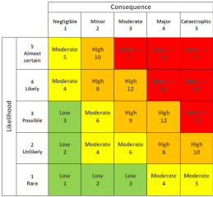
Core Health and Safety Mitigation program:
Bouldering spotting identified as moderate risk factor: to mitigate any potential risk Only experienced spotters, identified from the volunteer base will be permitted to spot, and a reminder of correct techniques will be gone through at the spotters briefing.

High risk are non applicable, as no top ropes, only bouldering.
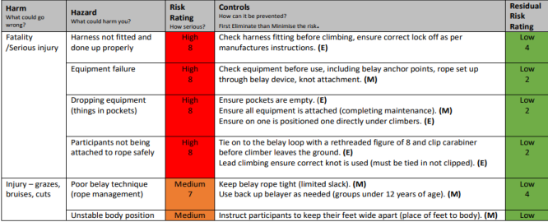4
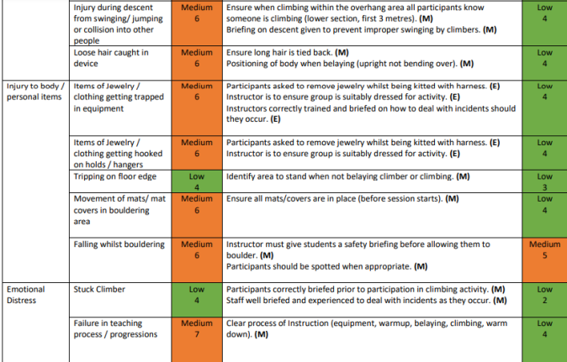5

Sport Specific Risk Assessment
Hazard or Risk identified. | Risk Level | Level of Control  (see previous page) |  |  |  |  | Action
What could go wrong? | Low  Med  High  Extreme | E  l  i  m  i  n  a  t  e | S  u  b  s  t  i  t  u  t  e | E  c  n  o  g  n  i  n  t  r  e  o  e  l  r | A  d  m  i  n  C  o  n  t  r  o  l | P  P  E | How will we prevent it? | Person  responsible | What we will do if it happens?
Fall from Height | High | No | No | Yes | Yes | Yes | Appropriate use of spotting techniques, if necessary, Only experienced adults are permitted to spot. These are hand picked in advance. | Event Manager | onsite first aid Emergency Services if Required
Falling objects | Med | No | No | Yes | Yes | No | Climbers to remove items from pockets, Effective group management and briefing | Event Manager | onsite first aid
Climber falling in a  dangerous position | High | No | No | Yes | Yes | Yes | Safe falling techniques to be taught/ reminded to climbers in H&S briefing. | Event Manager | onsite first aid Emergency Services if Required
Holds spinning /  breaking | Med | Yes | No | Yes | No | No | Condition of holds, monitored, on a regular basis Holds removed from wall or re-secured prior to commencing session. | Event  Manager  Route Setters | Route Setter to Repair or Replace before next Competitor
Muscle / Joint injuries | Med | No | No | Yes | No | Yes | Use appropriate climbing specific warm-up activities Recognition of overuse injuries, session managed with rests and recovery time | Team  Managers  Rock climbing gym staff | onsite first aid

6
3B: Venue Specific Risk Assessment & Management Plan – you may have already included the risks specific to your sport in the Event Risk Assessment above. If you have not done so, please provide a risk assessment specific to the hazards in your sport here OR if your NSO has supplied you with a Sport Specific Risk Assessment & Management Plan, please attach it to this document.
3B: Venue Safety Plan – including Emergency Evacuation Procedures. Please attach a copy of the Venue Safety plan to this document. The Venue Management will be able to supply you with this.
Venue specific plan attached
7
SECTION 4: Core Provisions and Communications.
Core Provisions: Please give details of the following core provisions as they apply to your event or state NA if they do not apply
Item. | Provider | Person  Responsible | Contact | Management Notes
First Aid and Medical services | Venue | Manager | info@northernrocks.co.nz | One additional personnel from volunteer base with expert level medical ability : Fiona McIver
Drinking water | Venue | ON site staff | info@northernrocks.co.nz | Available at counter
Food | Personal
Shade | Venue |  |  | Indoors
Toilets | Venue |  |  | Separate male and female toilets

Event Security | N/A
Waste Management | Venue |  |  | Bins onsite, recycling and general rubbish
Spectator Controls | Club leadership | Michael  O’Keefe | Michael.j.ok@gmail.com
Parking | Venue |  |  | Note Parking on-street, and venue car park.
Media |  |  |  | N/A

9
Event Communications Plan. Please give details of the following as they apply to your event.
Communication Item | Person Responsible | Audience | When? | Notes – eg Content
Pre Event Info – to schools, participants | Sandra Bolland | Schools | Prior the event | Flyer and school information for registering via College Sport.
Event Briefing – Safety Briefing, Event info for students, coaches, managers | Michael O’Keefe |  | On day – 10 min prior to start
Event Day Communications – Cancellations, changes, weather | Michael O’Keefe |  | On Day | Weather no issue – indoor event
Emergency Communications - evacuation, lost person,  emergency services, notification to schools/parents/media | Michael O’Keefe | Schools, parents, managers | On day | Contact details on google drive accessible online, hardcopy at event
Media information | Sandra Bolland | Parents/ Climbers | Prior & after the event | Flyer and event information on ACCS Facebook, &ASC website, College Sport website. After the comp results will be posted on all 3.

Covid Protocols:
Level 1: Standard sanitisation practises
Level 2: Provision of Zoono sanitiser product for all participants, 1m separation protocols in place
Level 3: Reschedule
10
Northern Rocks Activity Management Plans - Bouldering
Activity Description |  | Indoor climbing at low heights (max 4.5m) with use of fall impact crash mats. No use of ropes.
Location Description |  | Boulder Wall is an Artificial Climbing Structure with climbing holds set to routes or boulder problems.  This structure has top out boulders of 3.5m. Top Out Boulders allow climbers to climb to top of boulder and jump, downclimb or access stairs back to floor. Sections of the gym have structure without top out ability up to 4.5m in height.  The boulder mats are specifically designed to take impact from height and are used in accordance with manufacturers (Climb Mat) specifications. Northern Rocks mats consist of 3 layers of specialized foam, to 400mm in height and extend in width and length to ensure all possible landing areas are protected and in accordance with NZ Indoor Bouldering Regulations.
Supervision Structure Suggested capacity per Boulder Station = 5  No. of Stations = TBC Identify Blind spots |  | Public |  |  | Minimum of one supervisor  monitoring gym and facilities.  Capacity in gym 120 climbers  Users self-manage once inducted <13 yr old (ability equivalent) require direct adult supervision unless part of coaching or group classes  facilitated by approved staff. |  |  | Group |  | Direct Supervision; Suggested ratio =
 |  |  |  |  |  |  |  | 1:full class  with teacher |  | Induction wall. Have a Go experience with minimum coach interaction. Risk and safety supervision provided.
 |  |  |  |  |  |  |  | 1:15 |  | Induction wall. Have a Go experience with Coach Boulder Introduction Session
 |  |  |  |  |  |  |  | 1:10 |  | Structured Coach Boulder Introduction Session
 |  |  |  |  |  |  |  | 1:8 |  | Structured Coach Movement Development Session
 |  |  |  |  |  |  |  | 1:4 or 1:6 |  | Advanced Coach Movement Session / Clinic
 |  |  |  |  |  |  |  | 1:1 or 1:2 |  | Elite Coaching
Activity Policies | No Climbing until Northern Rocks standard facility induction completed. Climbing shoes must be worn when on the boulder walls. Each climber must be assessed as ‘able to fall’ or execute safe descent from the boulder walls, and briefed with safe climbing and spotting procedures.
Compulsory Instructor Equipment |  |  |  |  |  | First Aid at Front Desk, Climbing Shoes, Chalk & Bag, Tidy sports clothing. If climbing hair tied back, rings to be removed, bracelets to be considered for heat or injury swell.
Suggested Instructor Equipment |  |  |  |  |  | Hair tied back, no finger rings or any jewelry, spare hair ties, climbing tape.
Compulsory Participant Equipment |  |  |  |  |  | Sport clothing with no loose items, climbing shoes.
Suggested Participant Equipment |  |  |  |  |  | Climbing shoes, chalk & chalk bag, climbing tape, drink bottle
Pre-Activity Procedures |  |  |  | Risk, participant, programme checks. Set up briefing, shoe and climbing areas as required.
Group Briefing |  |  |  | How to Fall Safely. How to Down Climb. Where to walk around gym, along mats, under boulders, ensure no climbers above, training area and suitable ages, keep boulder mats clear, use of chalk, appropriate level to start for beginners, no running, parent supervision for children.  Hydraulic well to remain still whilst participants are using it.  Spotting Technique, and when to use.  Chalk Bag use, set standard of careful use of chalk. Dip hand in chalk, leave loose chalk in bag, rub hands together. All finger and tight wrist jewelry to be removed, explain how fingers and wrists swell up with use and if injury and swelling occurs it can increase severity.  Medical and Behavioral profile check with group leaders and or participants.  Blisters/flappers prevention and care discussed. Climbing tape provided and antiseptic cream. Wash hands.
Post Activity Procedures |  |  |  | Risk, Participant and programme review. Tidy up area as required. Suggestions and Improvements feedback.
Communication Procedures |  |  |  | Voice. When requiring a spotter (e.g. new move, minding an injury or beginner). Exchange between Spotter and Climber as follows: Spotter are you ready? Yes, ready.
Communication devices and coverage |  |  | Primary device |  |  |  | Voice |  | Mobile Coverage |  | NONE / POOR / GOOD / EXCELLENT

Page 1 of 5
 |  |  | Secondary device |  |  |  | Office Phone / Site Phone
Overdue Group Response |  |  |  | Direct supervision is required, therefore should not have overdue group separate from Coach or Supervisor.
Industry Accepted Qualification & Standards (Coach) |  |  |  |  |  |  |  |  | NR Foundation Coach Competency
Accepted Adult Helper / Assistant Competence |  |  |  |  |  |  | Group Management, Risk awareness, Ability to monitor and influence participant behavior, in particular to follow briefing and coach instructions. Spotting and Falling if assisting with instruction
Assistant Training |  |  |  | Under development
Recommended Minimum Participant Ability |  |  |  |  |  | None
Technical Advisors |  | Internal |  |  | Name: Sarah Hay Mobile: 021 203 4964 |  |  |  |  |  | External |  | Name: Will Hammersla Mobile: +614 3 304 9711
ASG / Standard | Activity Safety Guideline for Indoor Climbing and Climbing on Other on Artificial Structures V2 March 2016 – consider boulder application of processes
Prolonged Hazards |  |  | Untreated blisters / new holds are still abrasive / holds spinning
Previous significant activity specific incidents |  |  |  |  |  |  |  | Learnings from local and international gym visits and consultations:  Falling between mats or outside of mat zone has led to NR increasing landing area and have seals gap in mats Falling against doors or other climbing volumes on structure has led NR to improving their route setting to avoid any potential falls against these items.  Hand stuck between hydraulic wall hold and tension board-see incident report 28/09/20  Dislocated shoulder-see incident report 20/09/20  Dislocated elbow see Florence wu incident report

Risk Management
Specific Hazard | Management | Potential Severity 1-10 | Strategy  M-E
People (staff, participant, public)
Unsafe Fall | Route Setting to optimize clear fall area at more difficult problems.  Brief climbers to climb within their abilities.  High grade mats used. | 4 | I/E & A/T
Illness due to cross contamination | Group info packs to include direction around contagious illnesses and not coming to gym. Brief climbers on hand washing guidelines  Report any recent illnesses in medical forms | 2 | A/T &  PPE
Unknown medical backgrounds | Informed consent process  Medical disclosure  Staff first aid training | 4 | A/T
Drugs & Alcohol – public or other turns up to use gym under influence | Asked to leave the facility, not permitted to partake in activities, police reinforcement called if necessary | 3 | A&T
Friends coaching friends | Staff keeping an eye out for unsafe coaching techniques between friends. Climbing classes run by NR coaches offered. | 3 | A/T
Poor Rushed Briefing | Ensure staff are adequately trained for briefing in full and continually assess participants while they are bouldering to ensure safe practices are occurring | 5 | A/T
External Party Coaching | Boulder Foundation Coach Competency and Third Party Agreement between any external coaches and Northern Rocks | 5 | A/T
Understaffed / Inexperienced staff | Call in extra staff, implement briefings at set times, complete interview due diligence and competency process prior to hiring, staff training and ongoing staff review | 3 | E/S

Page 2 of 5
Unsupervised children; Slips and bruising or other injury due to mis behaviour | Restrict the children to climb on only orange or blue climbs on the top-out boulders, climb as a group, ensure adult supervision is happening if harder boulders or the non top-out wall is being attempted, staff to supervise if able. Rules and Expected positive behavior set. Strong group management and supervision. | 3 | A/T
Risk Management
Specific Hazard | Management | Potential Severity 1-10 | Strategy  M-E
People (staff, participant, public)
Youth using campus board and training area | Facility waiver stating gym rules, brief youth during induction, monitor behaviour, notice up next to training area | 3 | A/T
Fatigue | Encourage management of energy levels and body temperature. Ensure consumption of food and fluids for groups | 2 | A/T
Activity related stress or  embarrassment | Ensure a “challenge by choice” approach to activities. Monitor participants and encourage positive feedback from peers. | 3 | A/T
Participant Inattention, excitement, particularly youth, new climber | Strong group management skills, suitable coach ratios, induction completed and staff monitoring of participants | 2 | A/T
Participants using hydraulic wall | Brief participants to not move hydraulic wall while in use, bigger groups and holiday programs/coaching groups wall stays still unless directly supervised by an adult or coach | 3 | A/T
Equipment (activity, emergency, other)
Chalk and chalk bag | Encourage chalk bags to be left on the edge or next to boulder mat, rather than worn to reduce loose chalk in the gym. Staff monitor suitable chalking up methods and include in briefing suitable use of chalk | 3 | A/T
Damage to mat, spit in mat gap cover | Daily pre-use checks & Routine Checks  Block off area / Do not use after incident causing damage  Only reopen once repair completed | 2 | I/E
Damage to Holds, sharp edges, screws, edges, etc | Daily pre-use checks & Routine Checks. Route setters must not use damaged holds. Brief climbers n how to recognize and report. Remove or fix hold immediately or close climb until fixed. | 3 | I/E
Loose Spinning Hold | Report to staff.  Fix as soon as is practicable and no later than end of session / one hour. | 3 | I/E
Finger rings stuck from heat or injury swelling | Brief to remove all rings.  Where wedding ring is insisted on – ice and lubricant to remove. Allow participant to leave hands to cool down before trying to remove rings. | 2 | A/T
Environment (indoor)
Noise when rain on tin roof, music | Instructors to change their method of delivery for speaking with participants, wait, come closer, eye contact and delivery slowed down to ensure received  Noise level music policy | 2 | A/T
Other users distracting spotters | Group management, staff supervision, staff to educate participants if necessary | 3 | A/T
Other users encroaching in boulder station space | Group management, staff supervision, included in briefing / induction | 3 | A/T
Blind Spots | Staff periodically roaming gym, blind spots restricted youth area | 2 | A/T

Page 3 of 5
Rafter on Top Out Boulder | Foam applied to beams, included in briefing / induction, Monitor in daily checks, repair when necessary | 2 | I/E

Emergency Response – Specific to Bouldering – FIRST STEPS – Northern Rocks Emergency Procedures
STOP, THINK, ACT Refer to Incident Severity to help assess
Potential Severity 7+ = Dial 111
Assess any Potential Injury, Check Conscious. NB do not move if suspected awkward fall. Call 111 and ask for medical advice for suspected awkward fall.
Instructions for Ambulance – street address = Unit 17/101-111 Diana Dr, Wairau Valley, Auckland 0627. Opposite = 2 Cheap Northern Rock Partners Support = John Glaister 021 34 22 36, Sarah Hay 021 203 4964
Health & Safety Advisor = Fiona Ryder 021 024 95 914
Nearest Medical Centre | Nearest 24 Hour Accident & Medical Centre
Glenfield Urgent Care and GP  Urgent care; 8am–8pm, 365 days, just walk-in – no appointments. 436-440 Glenfield Road, Glenfield  09 444 4244 ext 1 | Shore Care Accident and Medical  24HR  Ground Floor, Sovereign House, Smales Farm, Takapuna 0800 746 732

Page 4 of 5
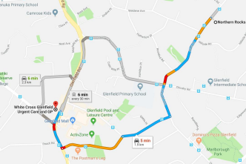Drive time = 5 min  Approx. 2km | 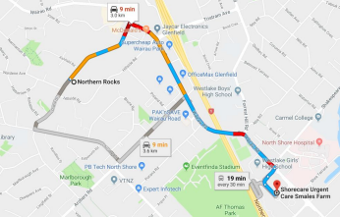Drive time = 9 min  Approx. 3km
Civil Emergency:
Fire Assembly Point: Building 9 carpark across from main reception entrance. In front of building 9, and not blocking driveway entrance
Earthquake -
Tornado / Storm Damage – Consider smaller rooms away from damage. Assess safe areas accordingly. Roll call.

