Auckland Climbing College Series – Event 4
2024 EVENT HEALTH & SAFETY PLAN TEMPLATE
SECTION 1: Event Information
Event Name: Auckland Climbing College Series: event 4 |  | This Plan Dated: 09/04/2024
Event Location | 33-47 Northside Drive, Westgate, Auckland
Event Date | 11/08/2024
Organisation delivering event | Auckland Sport Climbing
Number of Participants | Unknown – (160 estimate)
Number of Schools Participating | Unknown – 42 estimate

Event overview. Provide a brief summary of what your event will involve.
Sport Climbing – Indoor Climbing
The event is the fourth in a series of 4 events which includes 2 of the disciplines of Climbing Event 4: Boulder Co Climbing Gym
Competitors will have access to the entire Bouldering gym
Boulder climbs – climbing without ropes up to 3 meters high
SECTION 2: Event Personnel.

Name | Role | Responsibility | Contact Details
Sandra Bolland | Belayers  Manager | Belayers | accseries1@gmail.com
Chris Wade | Head Judge | Judges | chris@wadeysoft.com
Michael O’Keefe | MC & President ASC | Front of house | Michael.j.ok@gmail.com
John McKnight | Scoring software | Scoring Software | jmck010967@gmail.com
Sandra Bolland | Event Coordinator | Overall responsibility | accseries1@gmail.com
TBA | Disputes &  Discipline | Convening & Chairing disputes panel

.
2
SECTION 3: Risk Assessments and Management
3A: Sport Specific Risk Assessment & Management Plan
Risk Assessment Key
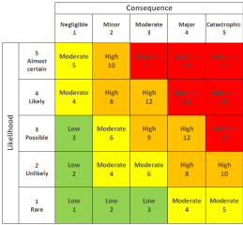
Core Health and Safety Mitigation program:
Bouldering spotting identified as moderate risk factor: to mitigate any potential risk Only experienced spotters, identified from the volunteer base will be permitted to spot, and a reminder of correct techniques will be gone through at the spotters briefing.

High risk are non applicable, as no top ropes, only bouldering.
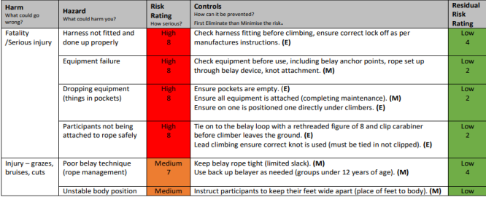4
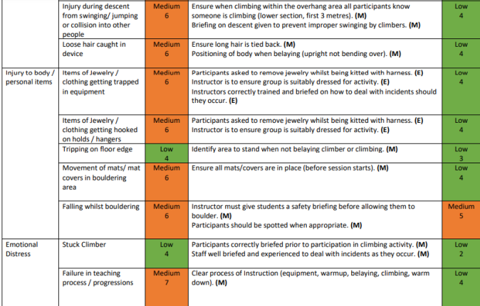5

Sport Specific Risk Assessment
Hazard or Risk identified. | Risk Level | Level of Control  (see previous page) |  |  |  |  | Action
What could go wrong? | Low  Med  High  Extreme | E  l  i  m  i  n  a  t  e | S  u  b  s  t  i  t  u  t  e | E  c  n  o  g  n  i  n  t  r  e  o  e  l  r | A  d  m  i  n  C  o  n  t  r  o  l | P  P  E | How will we prevent it? | Person  responsible | What we will do if it happens?
Fall from Height | High | No | No | Yes | Yes | Yes | Appropriate use of spotting techniques, if necessary, Only experienced adults are permitted to spot. These are hand picked in advance. | Event Manager | onsite first aid Emergency Services if Required
Falling objects | Med | No | No | Yes | Yes | No | Climbers to remove items from pockets, Effective group management and briefing | Event Manager | onsite first aid
Climber falling in a  dangerous position | High | No | No | Yes | Yes | Yes | Safe falling techniques to be taught/ reminded to climbers in H&S briefing. | Event Manager | onsite first aid Emergency Services if Required
Holds spinning /  breaking | Med | Yes | No | Yes | No | No | Condition of holds, monitored, on a regular basis Holds removed from wall or re-secured prior to commencing session. | Event  Manager  Route Setters | Route Setter to Repair or Replace before next Competitor
Muscle / Joint injuries | Med | No | No | Yes | No | Yes | Use appropriate climbing specific warm-up activities Recognition of overuse injuries, session managed with rests and recovery time | Team  Managers  Rock climbing gym staff | onsite first aid

6
3B: Venue Specific Risk Assessment & Management Plan – you may have already included the risks specific to your sport in the Event Risk Assessment above. If you have not done so, please provide a risk assessment specific to the hazards in your sport here OR if your NSO has supplied you with a Sport Specific Risk Assessment & Management Plan, please attach it to this document.
3B: Venue Safety Plan – including Emergency Evacuation Procedures. Please attach a copy of the Venue Safety plan to this document. The Venue Management will be able to supply you with this.
Venue specific plan attached
7
SECTION 4: Core Provisions and Communications.
Core Provisions: Please give details of the following core provisions as they apply to your event or state NA if they do not apply
Item. | Provider | Person  Responsible | Contact | Management Notes
First Aid and Medical services | Venue | Manager | nathan@boulderco.co.nz | One additional personnel from volunteer base with expert level medical ability : Fiona McIver
Drinking water | Venue | ON site staff | nathan@northernrocks.co.nz | Available at counter
Food | Personal or cna purchase
Shade | Venue |  |  | Indoors
Toilets | Venue |  |  | Separate male and female toilets

Event Security | N/A
Waste Management | Venue |  |  | Bins onsite, recycling and general rubbish
Spectator Controls | Club leadership | Michael  O’Keefe | Michael.j.ok@gmail.com
Parking | Venue |  |  | Note Parking on-street, and venue car park.
Media |  |  |  | N/A

9
Event Communications Plan. Please give details of the following as they apply to your event.
Communication Item | Person Responsible | Audience | When? | Notes – eg Content
Pre Event Info – to schools, participants | Sandra Bolland | Schools | Prior the event | Flyer and school information for registering via College Sport.
Event Briefing – Safety Briefing, Event info for students, coaches, managers | Michael O’Keefe |  | On day – 10 min prior to start
Event Day Communications – Cancellations, changes, weather | Michael O’Keefe |  | On Day | Weather no issue – indoor event
Emergency Communications - evacuation, lost person,  emergency services, notification to schools/parents/media | Michael O’Keefe | Schools, parents, managers | On day | Contact details on google drive accessible online, hardcopy at event
Media information | Sandra Bolland | Parents/ Climbers | Prior & after the event | Flyer and event information on ACCS Facebook,ASC & College Sport website. After, results will be posted on all.

Covid Protocols:
Level 1: Standard sanitisation practises
Level 2: Provision of Zoono sanitiser product for all participants, 1m separation protocols in place
Level 3: Reschedule
10

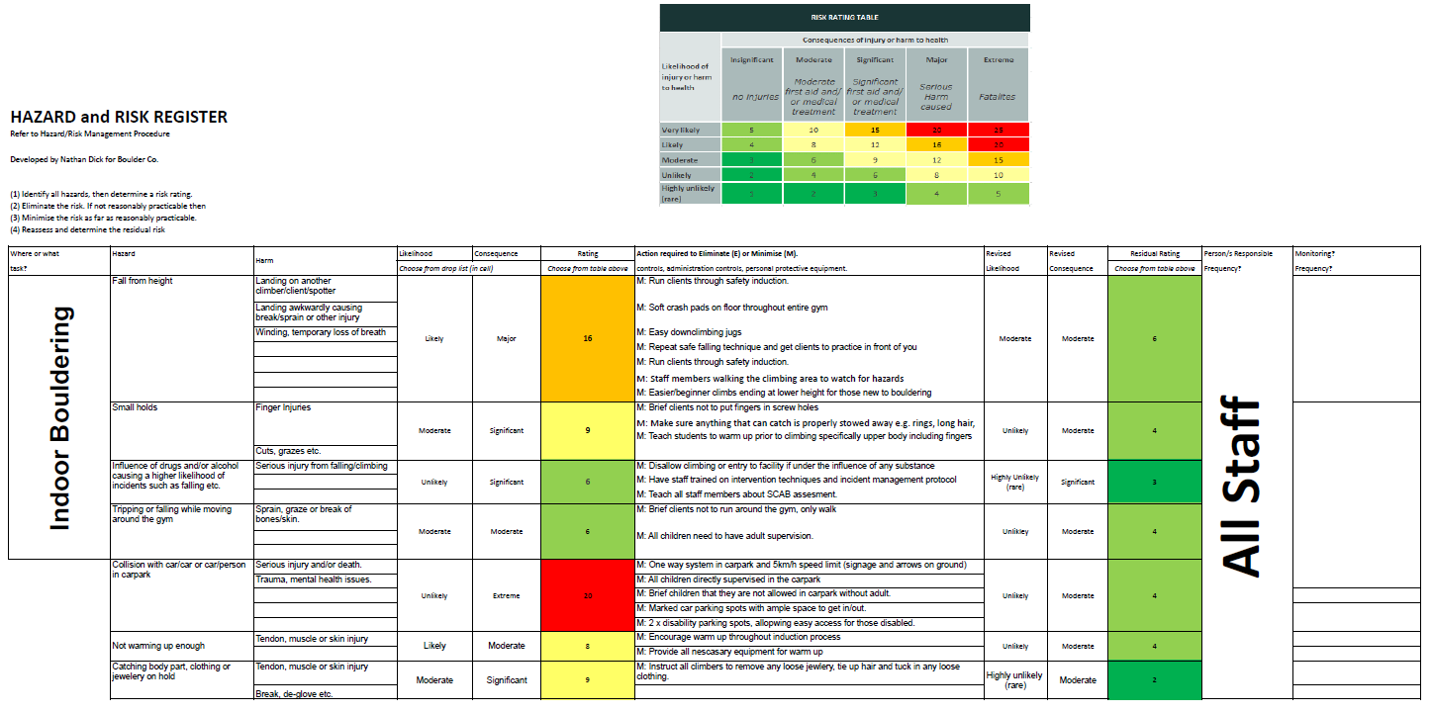

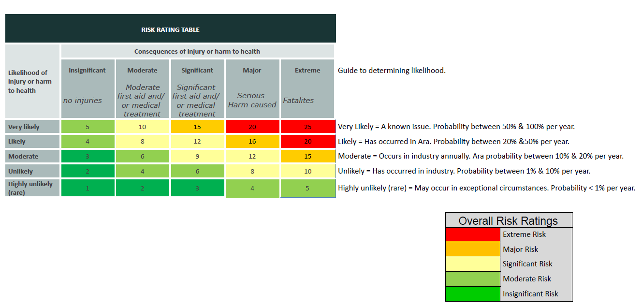

Responding to Emergencies Boulder Co
Emergency Response Guides have been developed for the following emergency
situations:
Office / base emergencies
Fire
Earthquake
Serious harm incident (level 4 or above)
Fire
Fire alarm will sound automatically. If it is not automatic, then a staff member will sound the alarm. This will automatically shut off the ventilation fans.
All staff will immediately turn off any fire-risk appliances (e.g. stovetop) if safe to do so, and assist evacuating customers out to the far end of the carpark.
The most senior staff member (wall manager) will assume the role of fire warden, making sure the facility is empty and safe. They will be the last person out of the building.
The manager will call the following people, in this order:
111 – Fire Department
Adam Caldwell - 021 228 2115, or if Adam is not available;
Nathan Dick – 020 410 23312
If the alarm goes off accidentally and there is no fire risk, all staff and clients will still follow the above procedure. Instead of calling 111, the manager will call Boulder Co's fire alarm management service on (09) XXXXXXX, to let him know that it was a false alarm.
The alarm will be turned off (Insert photos/procedures of turning off alarm), and the facility will be completely checked for any signs of danger by the manager.
Once the all clear has been given by the manager, everyone can re-enter the building.

Earthquake
In the event of an earthquake, everyone will need to safely make their way to a door frame and/or outside the building at the far end of the carpark, away from any tall structures.
Anyone currently climbing will be told by staff members to downclimb immediately and then make their way to one of the above areas.
If anyone is injured, the building is damaged and/or the manager has any concerns, they will call 111 and follow all instructions of the emergency responders.
The building will only be re-entered once it is safe, decided by either the manager or the emergency responders.

Serious Harm/Injury
The wall manager or the most senior staff member will be responsible for delegating specific jobs to people;
First aid – most advanced first aider on site Call emergency services
Crowd control – evacuate if necessary
Upmost priority will go to keeping the person(s) injured in as little danger as possible, without compromising the safety of anyone else in the facility.
The manager will follow instructions of the emergency responders and only resume activity if it is safe to do so.

